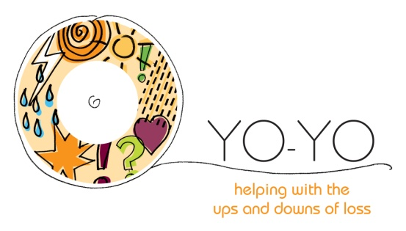
THE YO-YO PROJECT CHILDREN & YOUNG PERSONS
BEREAVEMENT COUNSELLING REFERRAL

Please complete this form fully, providing as much information as you can. Referrals will be accepted into the service if they meet the Yo-Yo Project referral criteria.

Family details
Name of parent/carer: | Relationship to child/young person:
Address:  Post Code: | Telephone no.  Mobile no.  Email:

Please list below the child/young person you are referring to the service
(Separate forms must be completed for additional children/young people)
Child/Young Person’s Name: |  | D.O.B: | Age:
Ethnicity: | Gender: | Language: | Religion:
School: |  | GP Details:
Disability/Medical conditions:

Learning/Behavioural needs:

Is there anyone else involved in their care:

REFERRALS ARE WELCOME ONLY FROM 6 WEEKS AFTER THE DATE OF DEATH

Please provide details about the deceased
Name of deceased: | Relationship to child/young person: | Age:
Circumstances/Cause of death: |  | Date of death:
Please describe the impact of the bereavement on the child/young person and highlight areas for concern (continue on a separate sheet if necessary):

Any other significant events/risks: (e.g. issues around birth/infancy, childhood development, relevant family events, bereavements, losses, suicidal thoughts or feelings)

Family Tree (helpful): Example
Twins
Kevin (18)
Mary (14)

Details of person referring
Name: | Relationship to child/young person:
Is this information the same as on Page 1 Y ☐ N ☐
If No, please complete below
Address:  Post Code: …………………………………... | Telephone no.  Mobile no.  Email:

Consent
(All children/young people MUST consent to accessing the service before we meet them. We will not progress referrals without their consent/knowledge)
Is the child/young person aware of the referral? Y ☐ N ☐
If No, please give reasons:

Is the parent/carer aware of the referral: Y ☐ N ☐
If No, please give reasons:

Signature:

Print name:

Date:

Please send this form or email to: The Yo-Yo Project, Farleigh Hospice, North Court Road, Chelmsford, Essex CM1 7FH Tel. No. 01245 457416 Email: yoyoproject@farleighhospice.org

The Yo-Yo Project referral criteria is available to view on the website – www.farleighhospice.org/bereavement-support. Farleigh Hospice will retain information on this form in line with their protocol, policy & GDPR regulations. You are welcome to see these policies upon request & access information under GDPR guidelines.

The Yo-Yo Project is a part of Farleigh Hospice Services
Registered address: Farleigh Hospice, North Court Road, Chelmsford CM1 7FH Tel: 01245 457416
Email: Bereavement@farleighhospice.org Web: www.farleighhospice.org
Registered in England with limited liability no. 1619905 – Charity registration no. 284670

